NEWSLETTER | DECEMBER- 2025
COLLEGE NAME | GOVERNMENT DEGREE COLLEGE
ADDRESS | BARUVA - 532263, SRIKAKULAM District
VISION | To establish a just and humane society by imparting quality education, ethical values, value added knowledge with global standards in the down-trodden sections
EDITORIAL BOARD | Month | Year | Vol | Issue
Dr.D.Rama Rao Principal  SriP.RamaKrishna Vice Principal  Sri. B.Rambabu IQAC Coordinator | DEC | 2025 | 12 | 2
 | CONTENTS |  |  | DETAILS
1. Staff Achievements (Awards and
Achievements )
 | 2. Student's Achievements (Awards and Achievements) |  |  | . 6-7 KODANDA AND HEMA SUNDAR AND GIRLS TEAM GOT MEDALS
From Principal’s Desk ( Brief Overview of all events | 3. Community Corner ( Extension and  Outreach Activities )
4.News from Departments
(Departmental activities)
 | 5. Alumni Corner
 | 6. Sports and Cultural Corner
7. Research and Capacity Building Programmes (MoUs,
Training’s organised by the Institution, HVPE Activities)
 | 8. Upcoming Events
9. Any other important and Relevant Information related to the Institution like
donations by Philanthropists, Community etc.
 | 10. Press Clippings |  |  | 18-28

01-12-2025
INTERNATONAL AIDS DAY
GOVT DEGREE COLLEGE , BARUVA HAVE CONDUCTEDAWARENESS PROGRAMME AND RALLY IN THE ROADS OF TOWN , BARUVA TO MAKE MORE AWARENESS ON THE DISEASE CALLED AIDS i.e., CAUSED BY THE VRUS CALLED HIV .
AND ALSO WE CONDUCTED THE POSTER PRESENTATON AND ESSAY WRITNG AND DEBATE COMPETTONS TO STUDENTS TO MAKE MORE AWARE ON THE DISEASE CALLED AIDS AND its PREVENTONS.
THE PRINCIPAL Dr D RAMA RAO , VICE PRINCIPAL Sri P.RAMA KRISHNA AND ALL LECTURERS HAVE PARTCPATED N THE RALLY AND EVENT ACTIVELY

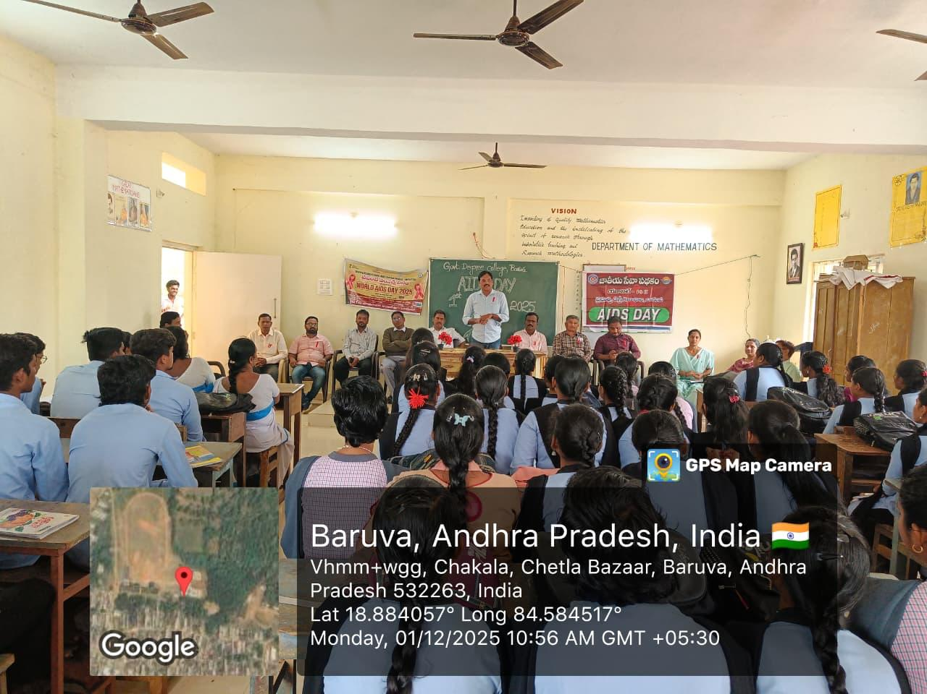
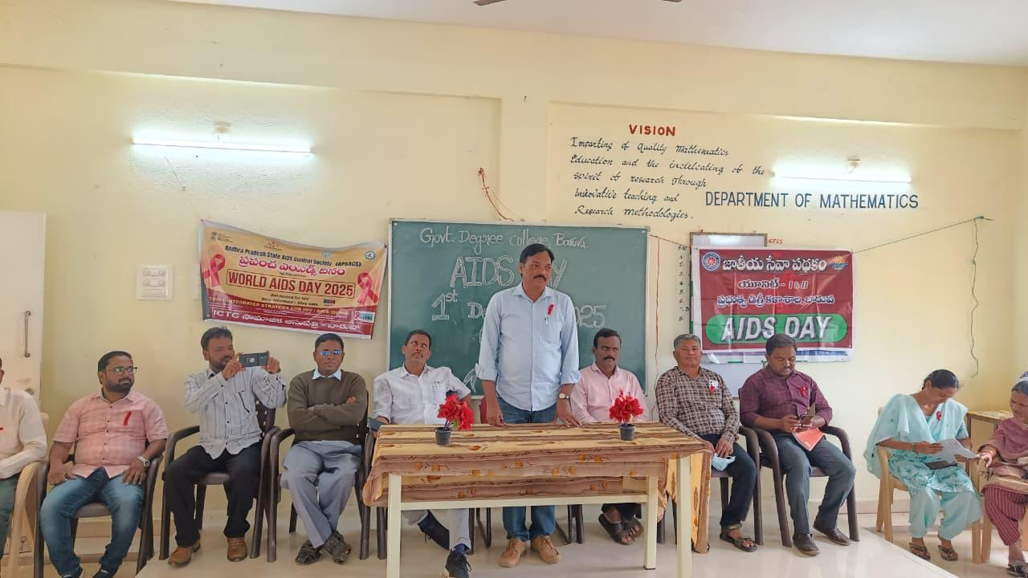 | 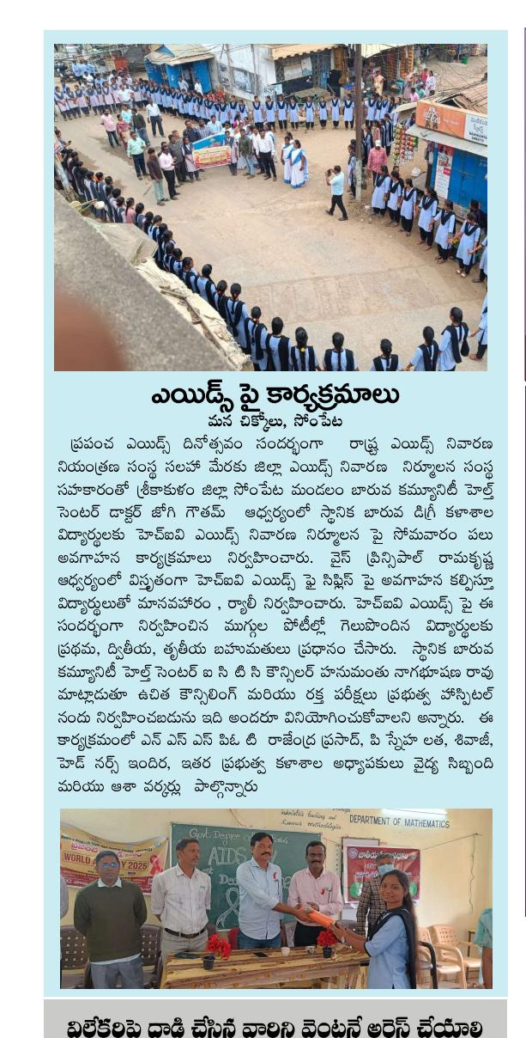
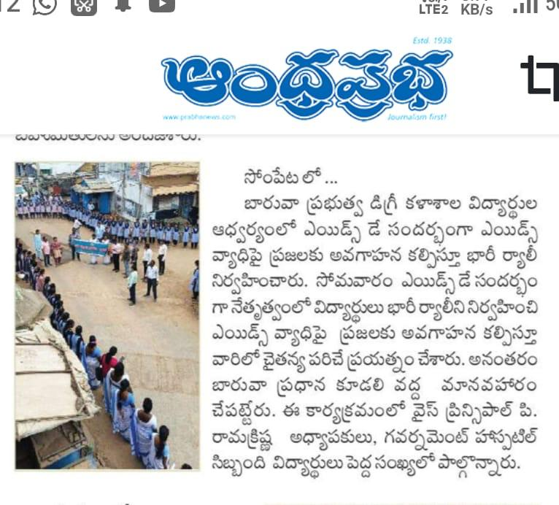 | 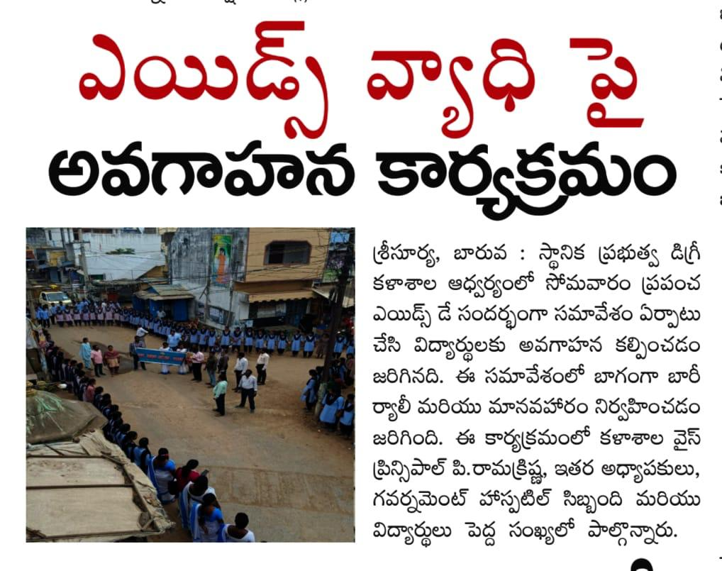

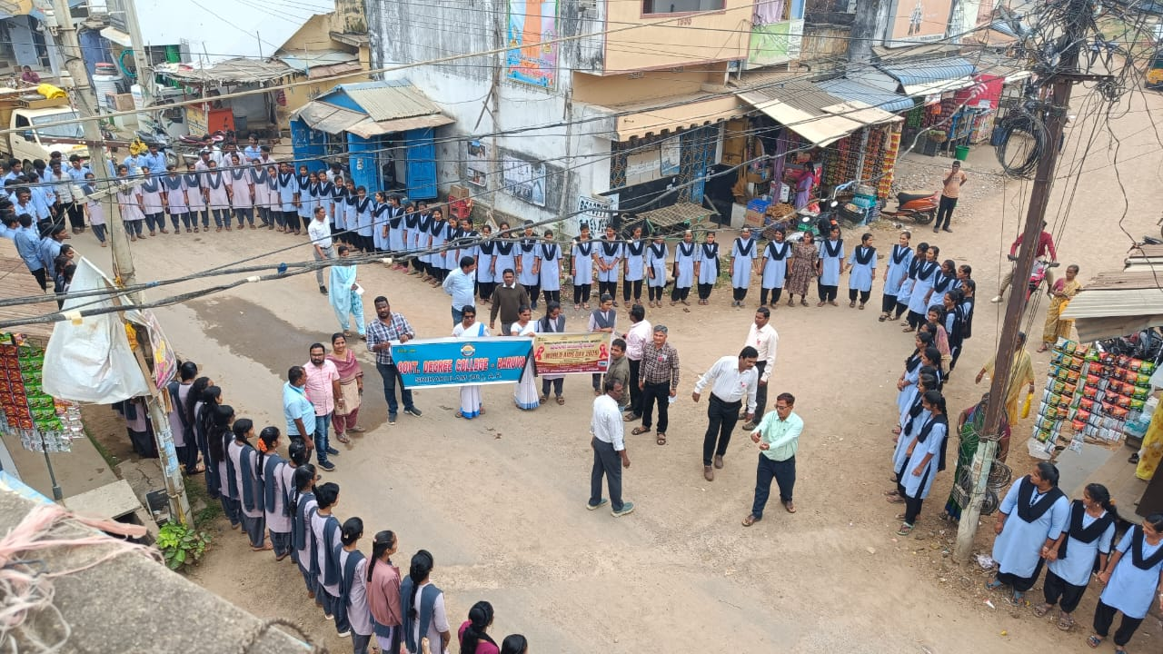 | 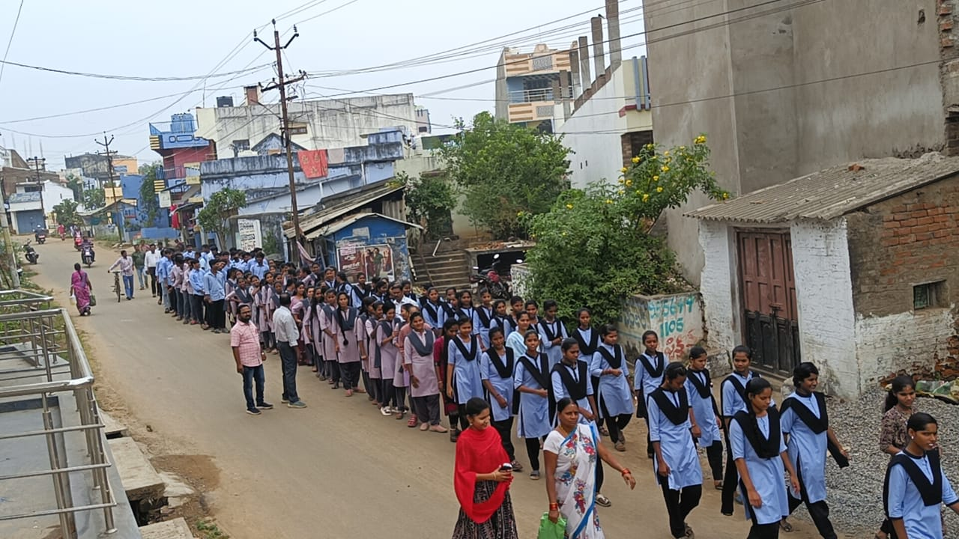
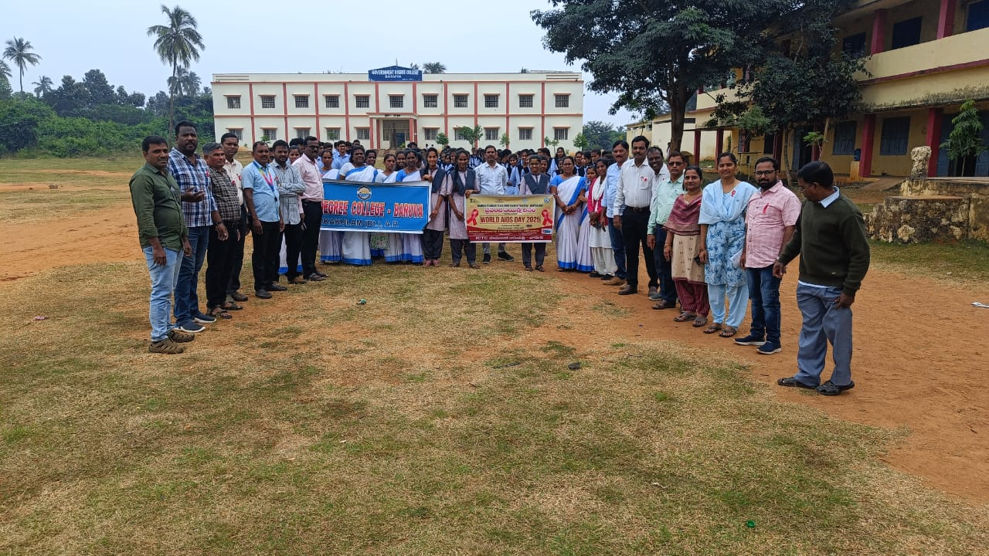 | AIDS DAY-2026  AWARENESS RALLY

POSTER PRESENTATION @ AIDS DAY 2026  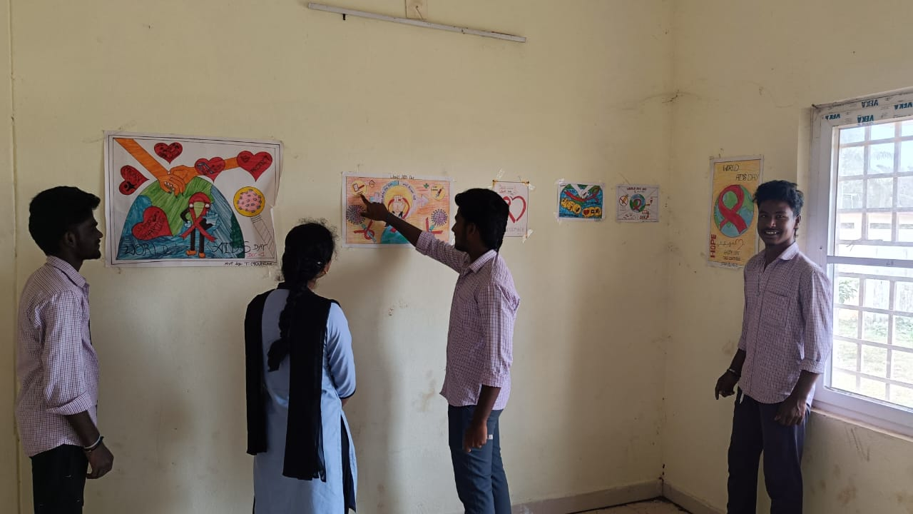 | POSTER PRESENTATION @ AIDS DAY 2026  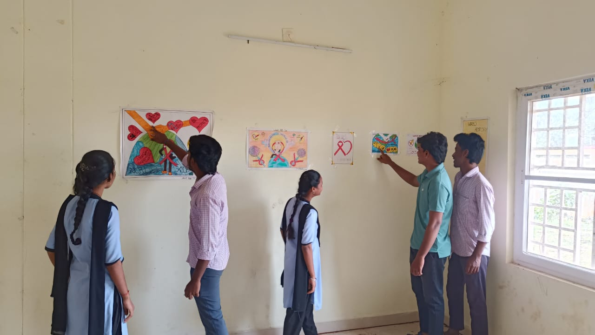
POSTER PRESENTATION @ AIDS DAY 2026  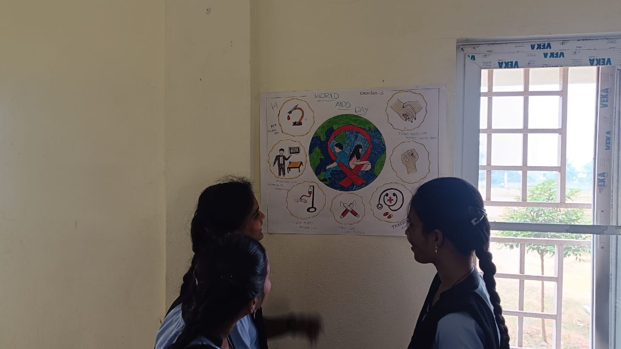 | PRIZE DISTRIBUTION @ AIDS DAY 2026  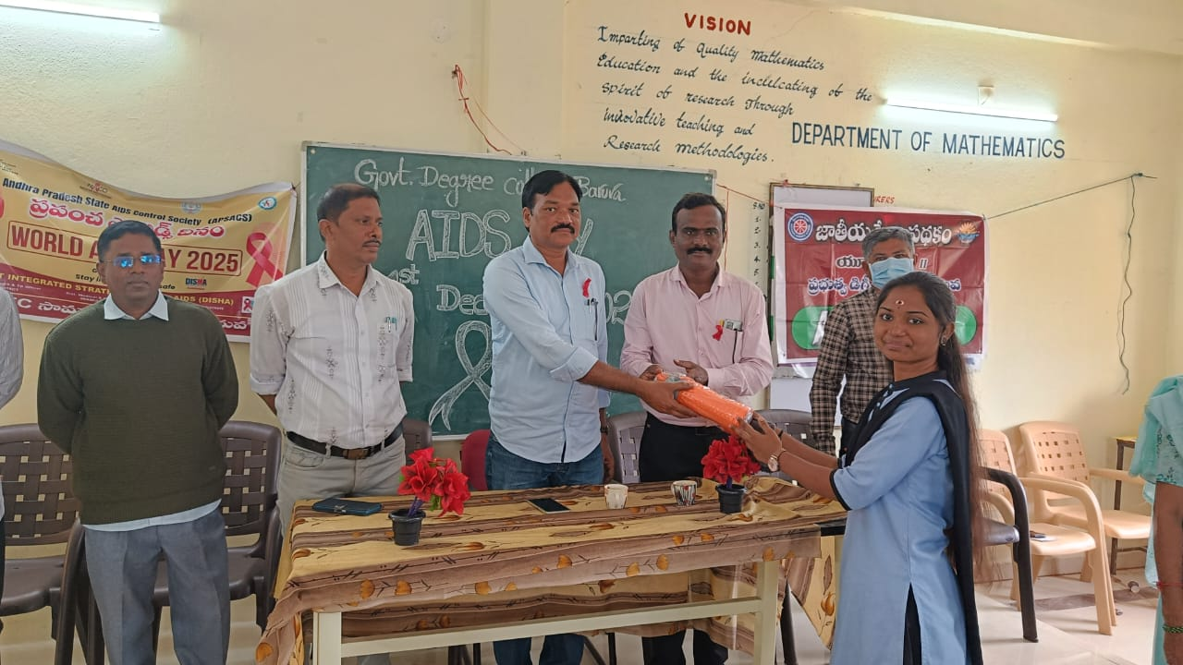
PRIZE DISTRIBUTION @ AIDS DAY 2026  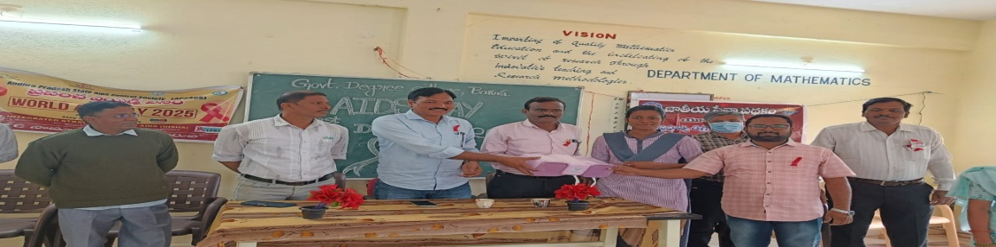 | PRIZE DISTRIBUTION @ AIDS DAY 2026  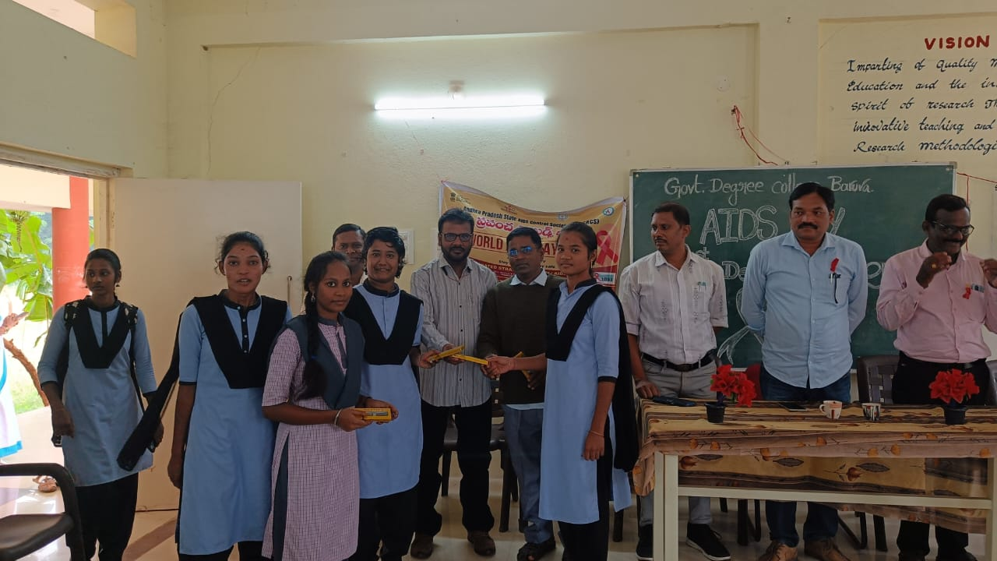

03-12-2025
NEHRU YUVA KENDRA STATE SPORTS MEET @ SRIKAKULAM
OUR COLLEGE STUDENTS AND LECTURER IN PHYSICAL EDUCATON Sri K RAMA RAO HAVE ATTENDED THE SPORTS MEET CONDUCTED BY NEHRU YUVA KENDRA AT SRIKAKULAM ,KODI RAMMOORTHY STADIUM.  AND OUR COLLEGE GIRL STUDENTS ACHIEVED 2nd PRIZE IN KHO-KHO AND STUDENT BOYS NAMED K.KODANDA GOT 1ST PRIZE N 100 METER RUNNING and CH.HEMA SUNDAR ACHIEVED 2ND PRIZE IN SHUTTLE BADMINTON.  THE PRNCIPAL AND ALL THE LECTURERS HAVE PRAISED THE COLLEGE STUDENTS | 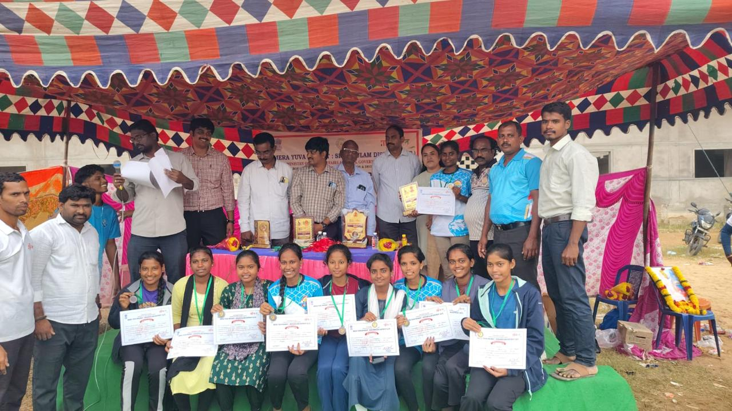
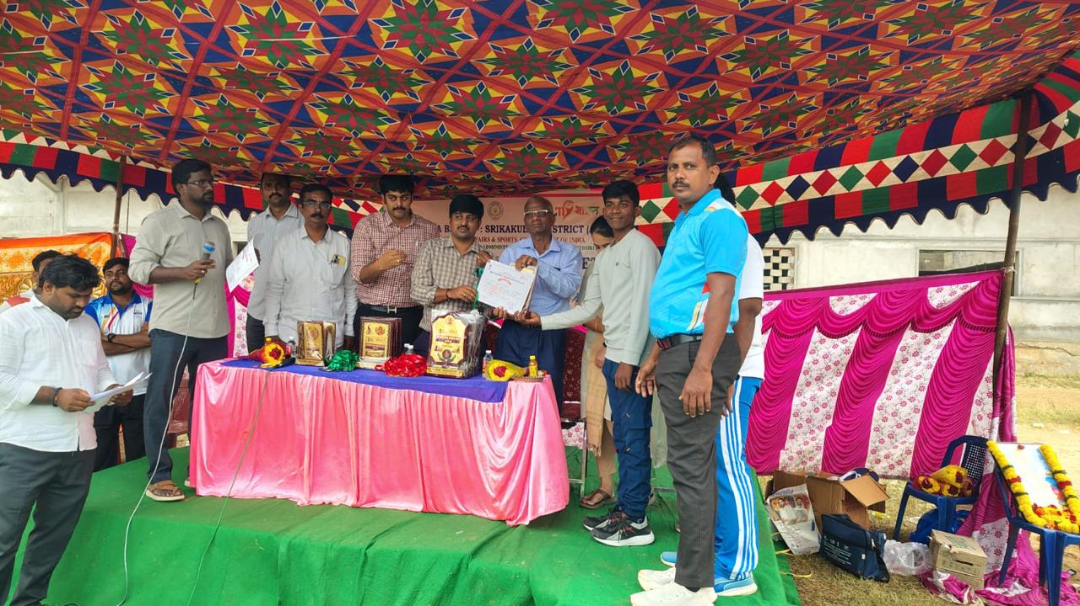 | 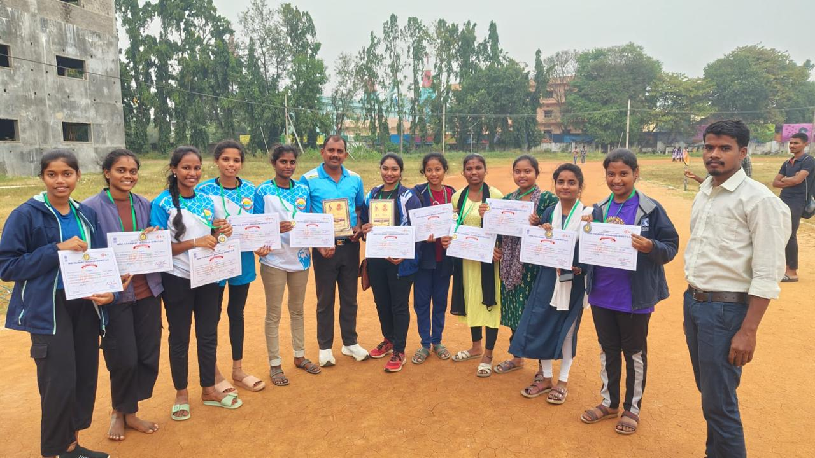

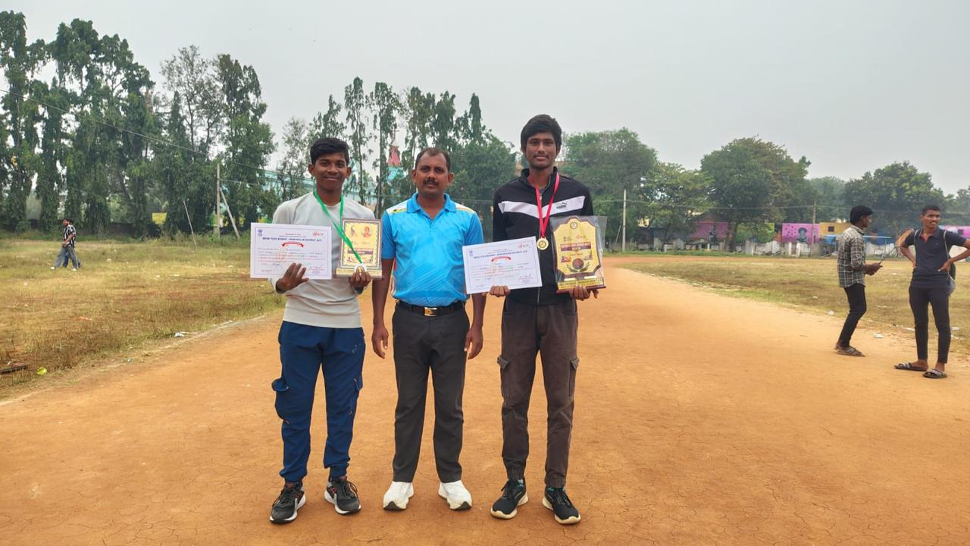
05-12-2025
ANTI DRUG AWARENESS PROGRAMME
ANTI DRUG AWARENESS PROGRAMME ORGANISED BY EAGLE CLUB,OF BARUVA, DEAPARTMENT OF POLCE.  CI MANGARAJU AND SI HARBABU AND THE PRINCPAL AND NSS PO-I and NSS PO-II AND ALL THE LECTURERS AND STUDENTS HAVE PARTICIPATED N THE PROGRAMME. | 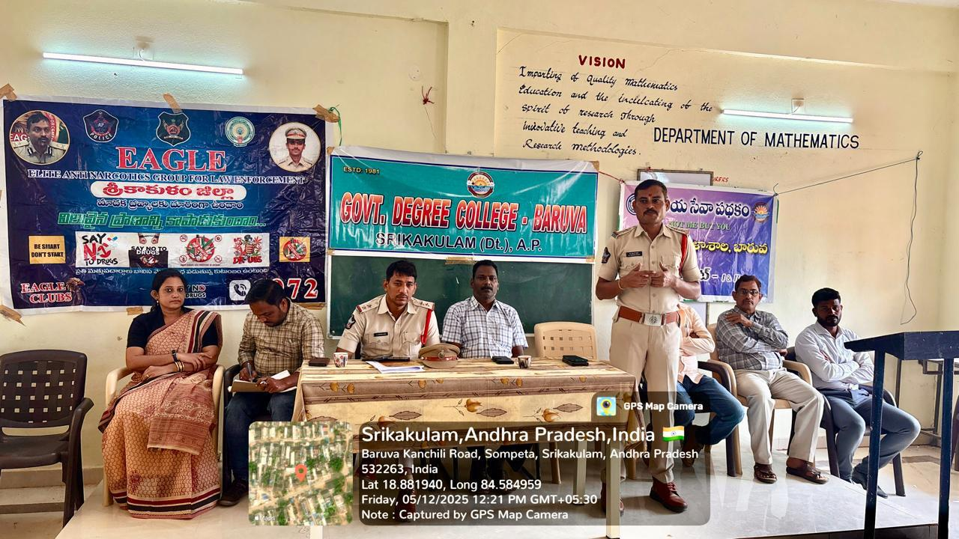
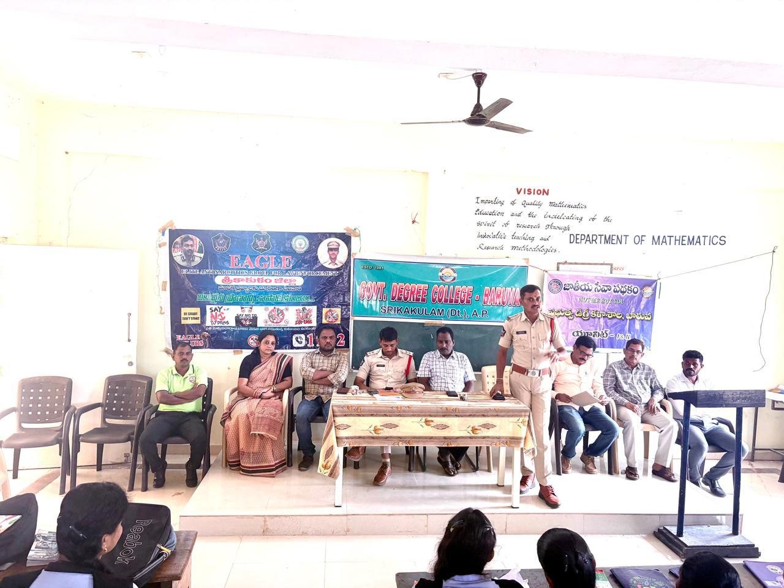 | 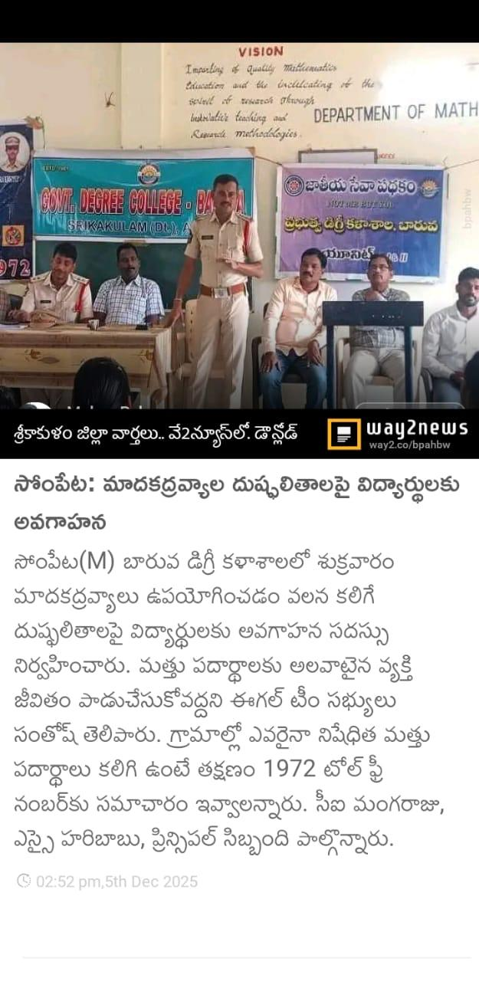

06-12-2025
Dr B.R.AMBEDKAR MAHA PARI NIRVANA DIWAS
THE PRINCIPAL AND THE STAFF HAVE ATTENDED AND REMEMBERING THE GREAT PERSONALITY OF INDIA Dr.B.AMBEDKAR ON HIS DEATH ANNIVERSARY ,THE PROGRAMME WAS ORGANISED BY DEPARTMENT OF POLITICAL SCIENCE,GDC BARUVA.
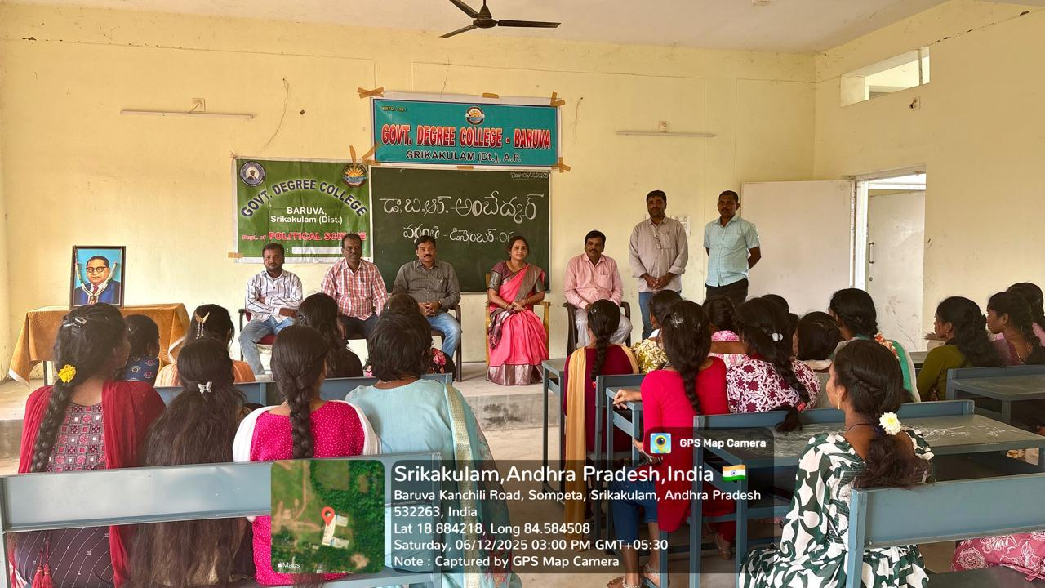 | 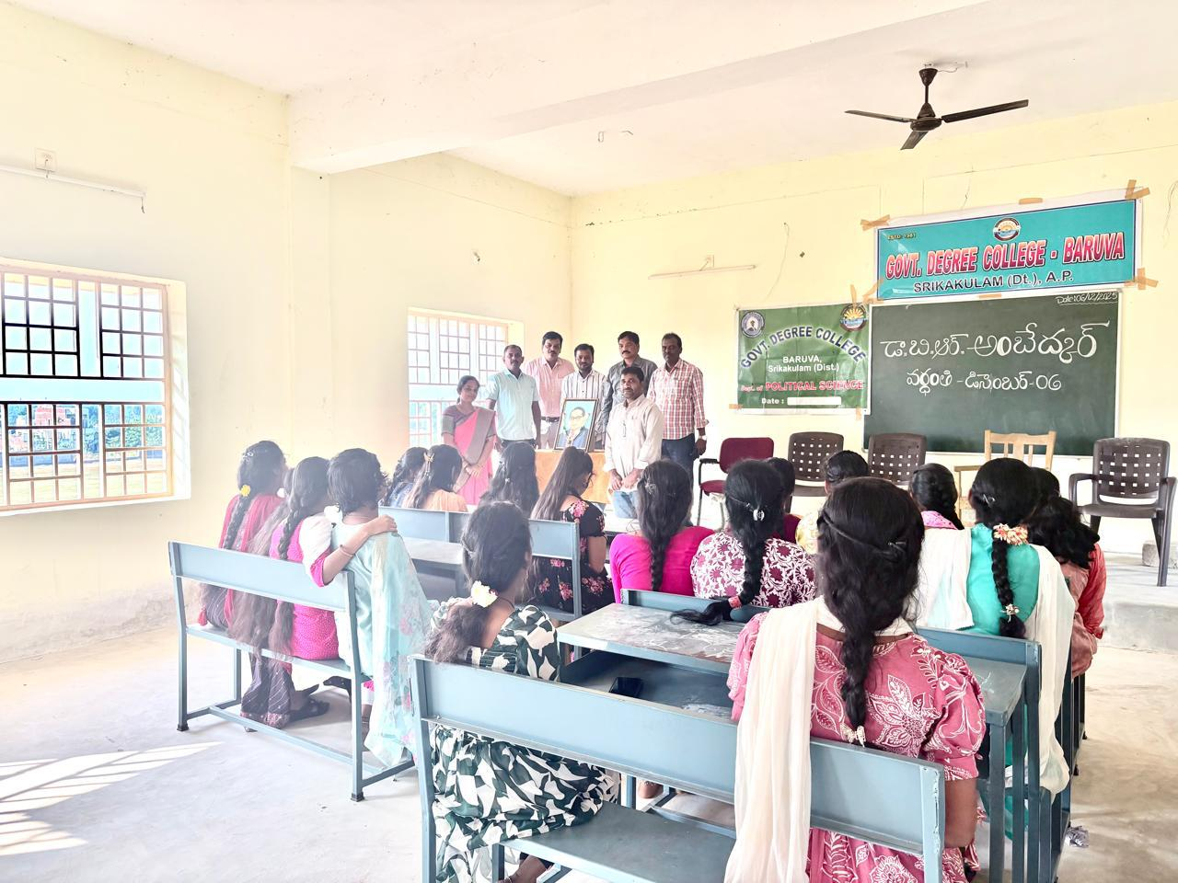
10-12-2025
INTERNATONAL HUMAN RIGHTS DAY
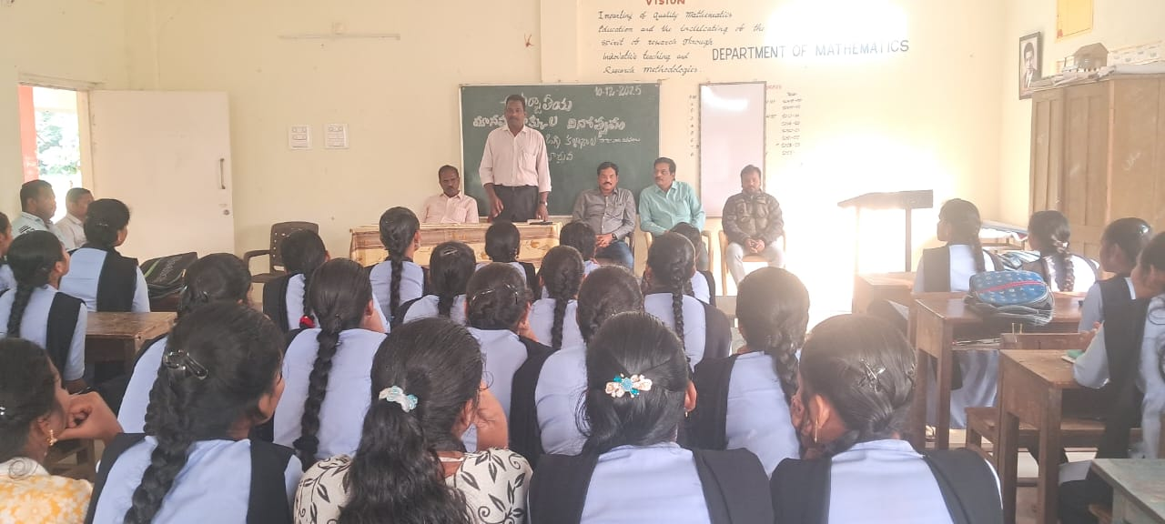 | GDC BARUVA , THE PRINCPAL HAVE CONDUCTED A GREAT PROGRAMME ON INTERNATONAL HUAMN RGHTS DAY AT OUR COLLEGE AND STUDENTS AND STAFF HAVE ATTENDED AND ADVOCATE KALLA.RAJESWARA RAO HAVE TAKE SPECIAL GUEST ROLE AND DELIVERED SPEECH AND ROLE AND MPORTANCE OF HUMAN RGHTS AND HOW TO DEAL WTH LAW TO PROTECT OUR BASIC RIGHTS
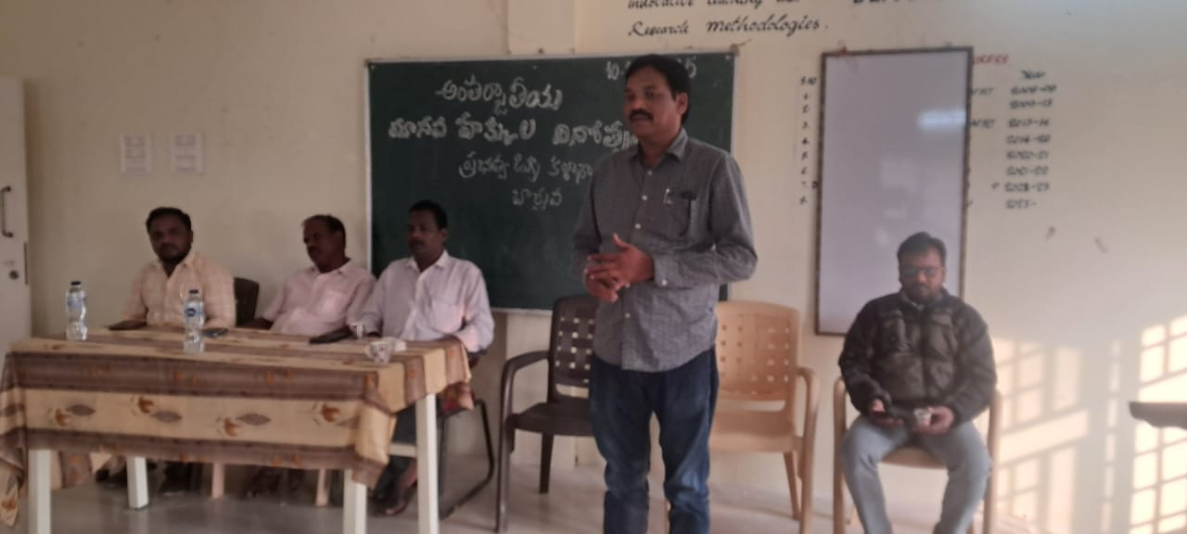 | 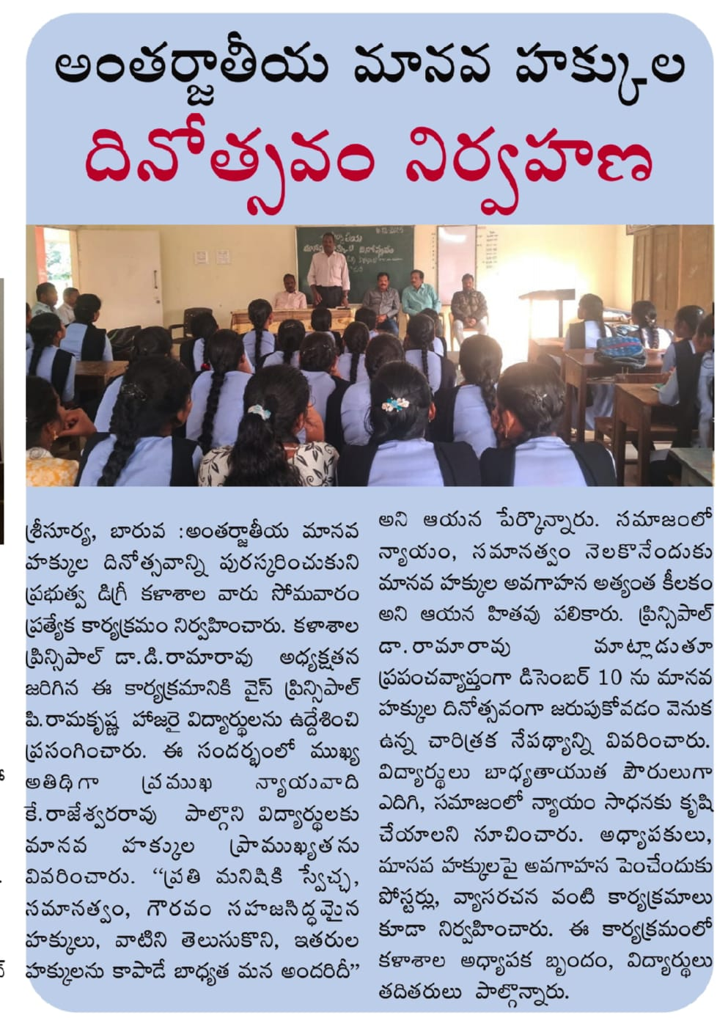

15-12-2025
ATMARPAN DIWAS

THE PRINCIPAL AND ALL THE STAFF HAVE REMEMBERING THE CONTRBUTONS DONE BY AMARAJEEVI Sri POTTI SRIRAMULU INTO GET ANDHRA RASTRA ON HIS DEATH ATMARPAN DAY.

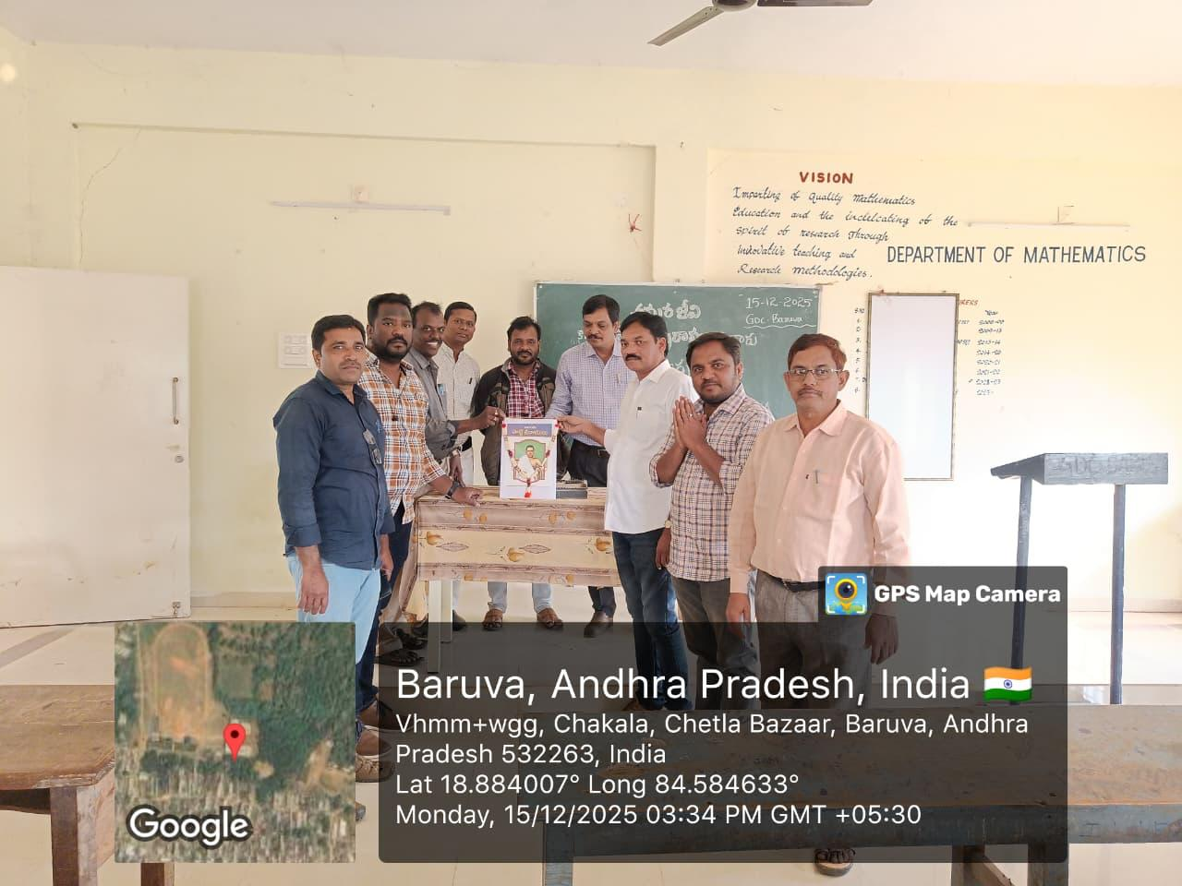

17-12-2025

NATIONAL WEBINAR- BOTANY
“ PATH TO ATTAIN SUSTAINABILITY THROUGH PLANT SCIENCE ”

Smt.P.SNEHALATHA ,HOD.,DEPARTMENT OF BOTANY ORGANISED ONE DAY NATIONAL WEBNAR ON “ PATH TO ATTAIN SUSTAINABILITY THROUGH PLANT SCIENCE ”
THE KEY NOTE SPEAKER PROF..FELIX BAST , CENTRAL UNIVERSITY OF PUNJAB AND Dr P.RAMA RAO,PRINCIPAL ,GDC THOGARAM AND Dr SARA PALAPARTHY,LECTURER IN BOTANY ,GDC RAMA CHANDRA PURAM HAVE DELIVERED THEIR LECTURE ON THE TOPIC REGARDS.

THE PRINCIPAL , STAFF AND ALL THE STUDENTS HAVE PARTICIPATED N THE WEBINAR.AND ALL THE PARTICIPANTS HAVE RECEIVED THE CERTIFCATES FROM THE DEPARTMENT OF BOTANY , GDC BARUVA.

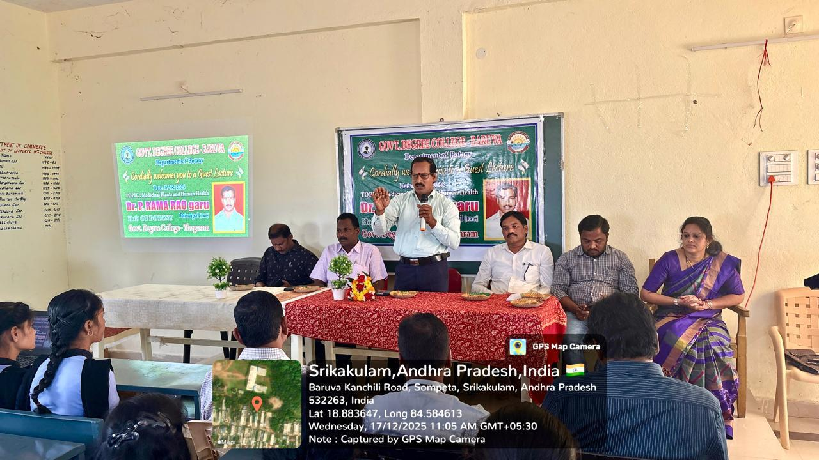
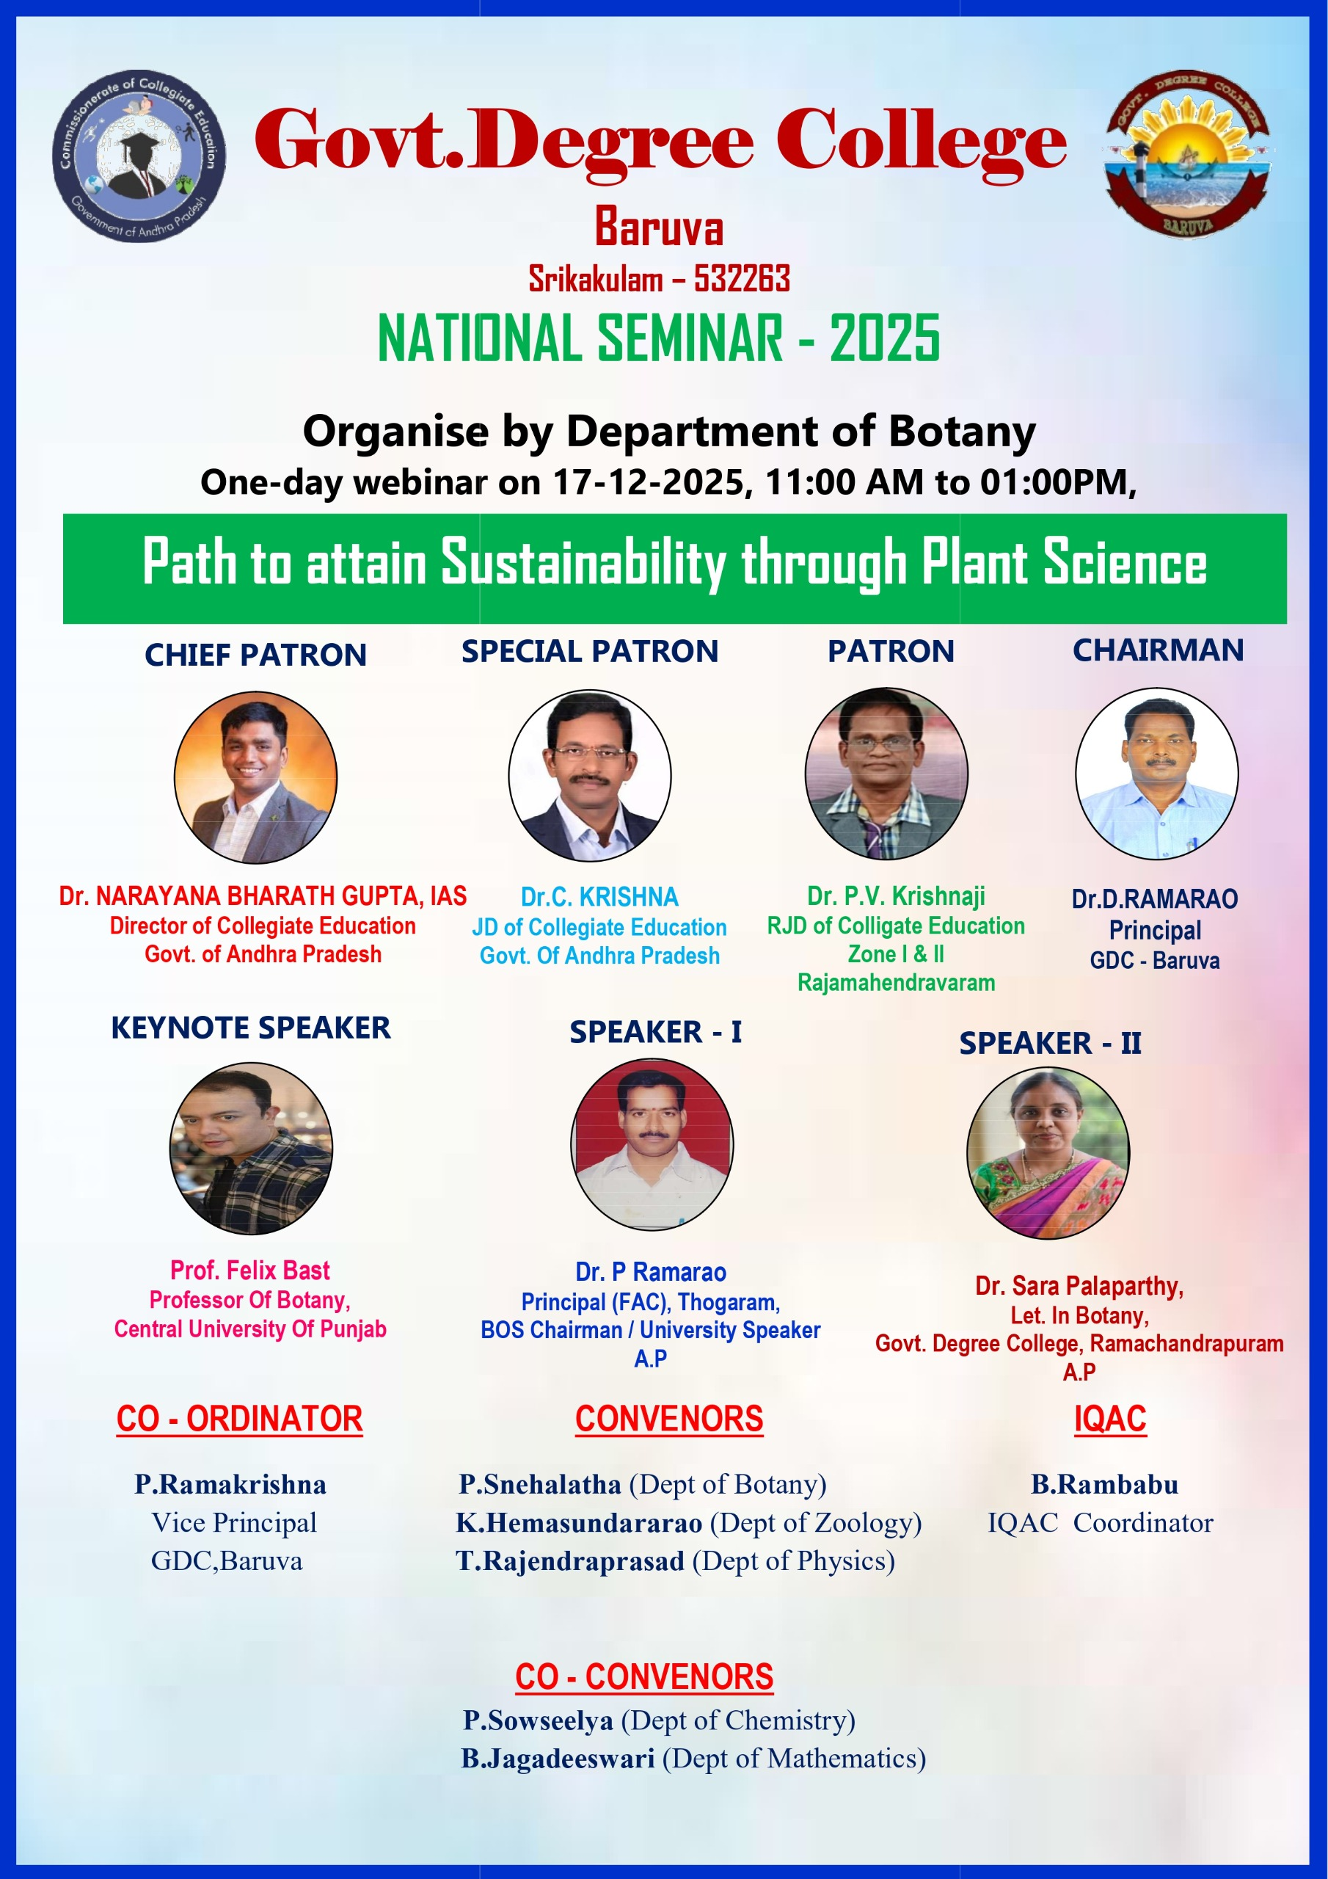
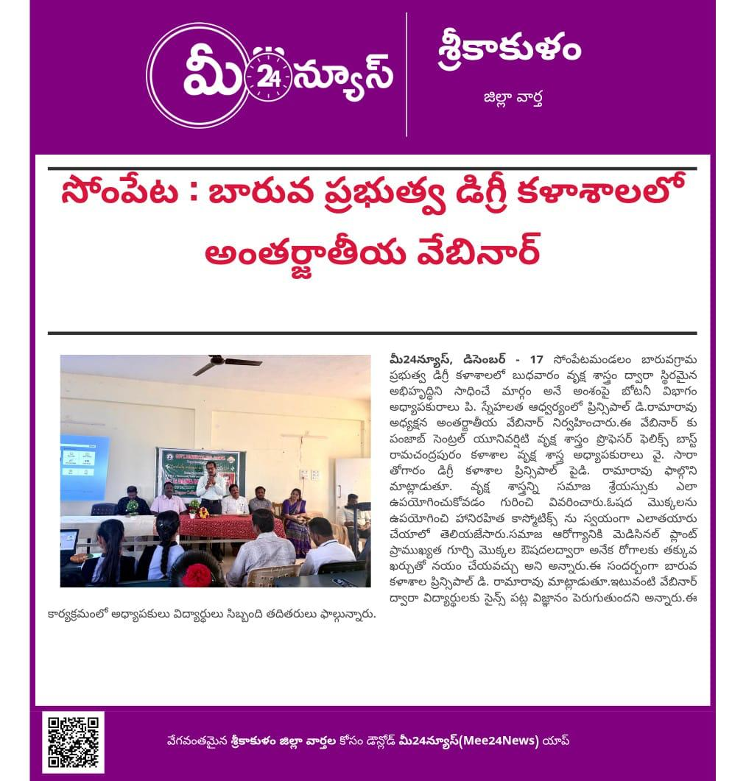 | 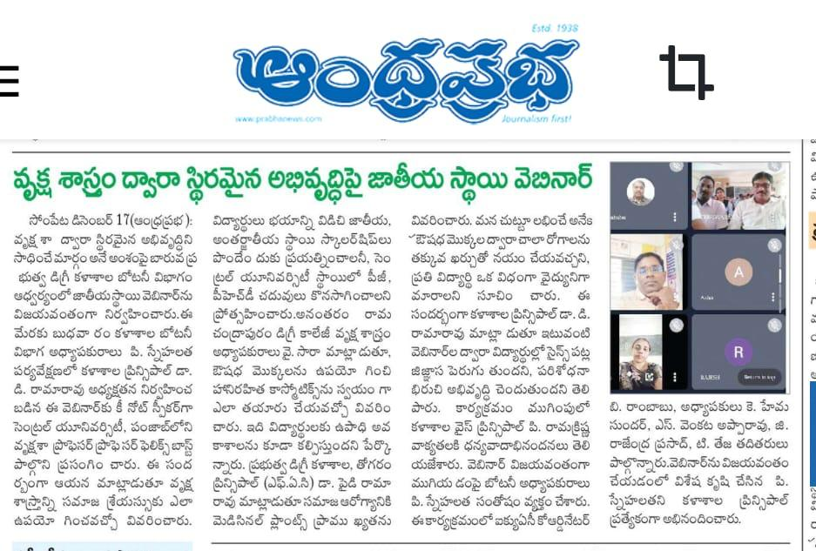
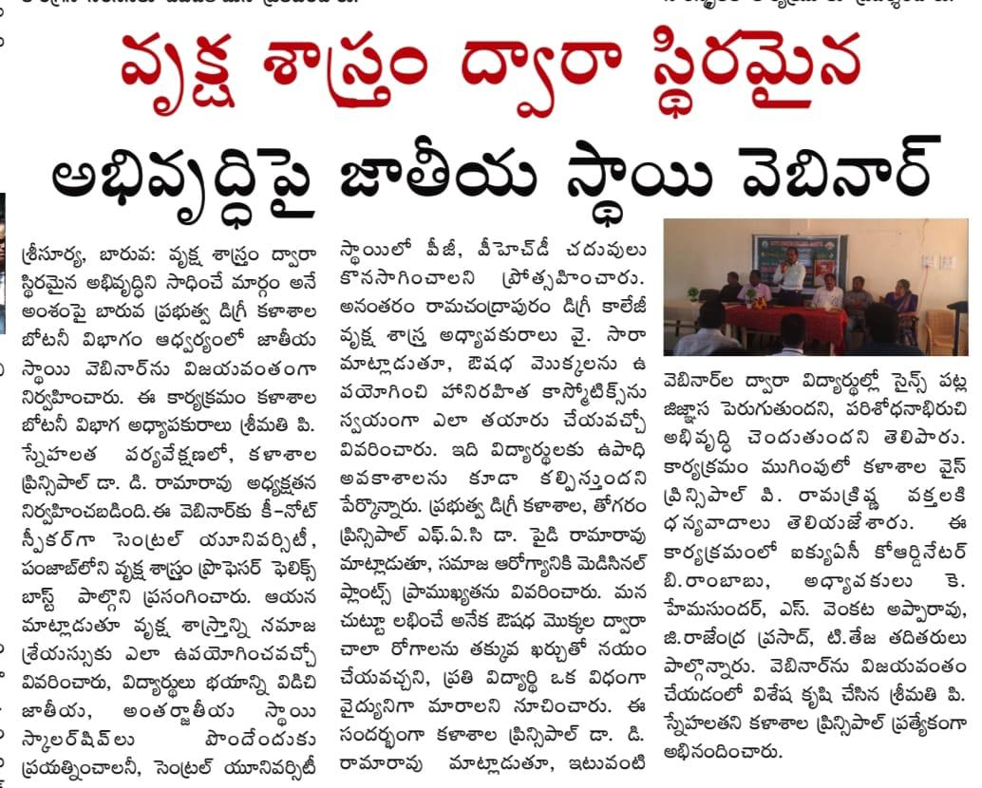 | 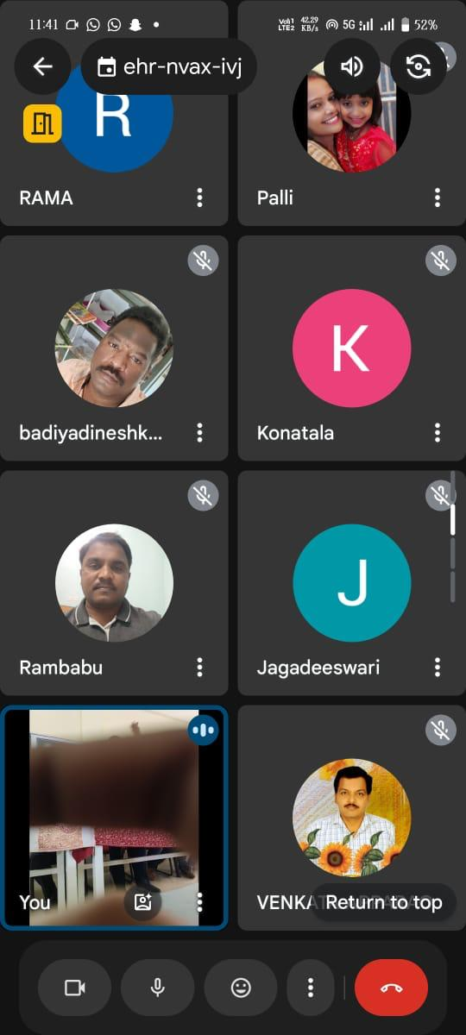

17-12-2025
GUEST LECTURE IN DEPARTMENT OF BOTANY
Smt.P.SNEHALATHA , HOD, DEPARTMENT OF BOTANY ORGANISED A GUEST LECTURE ON “MEDICINAL PLANTS ANDS HUMAN HEALTH” BY Dr.P.RAMA RAO ,PRINCIPAL ,GDC THOGARAM ,BOS CHAIRMAN Dr BRAU SRIKAKULAM .
HE DELIVERED THE USES OF DIFFERENT MEDICINAL PLANTS AND HOW THEY CURE DIFFERENT DISEASES.
HE CLARIFIED DOUBTS OF STUDENTS.

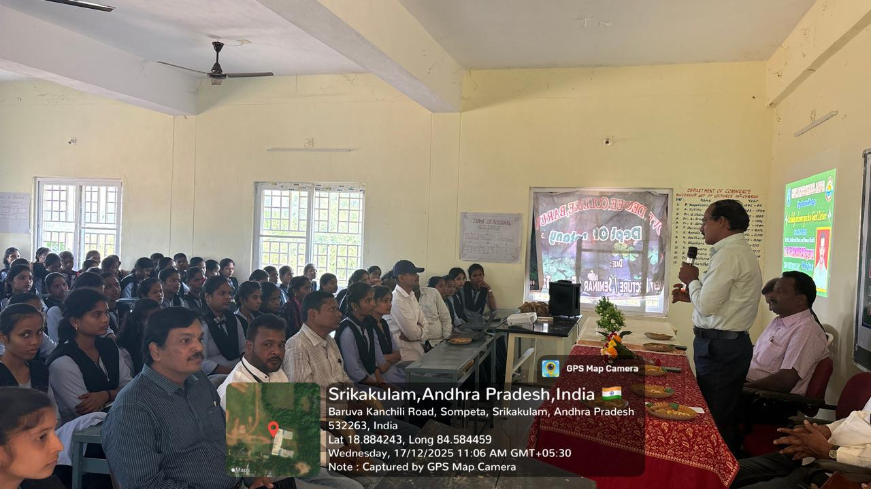 | 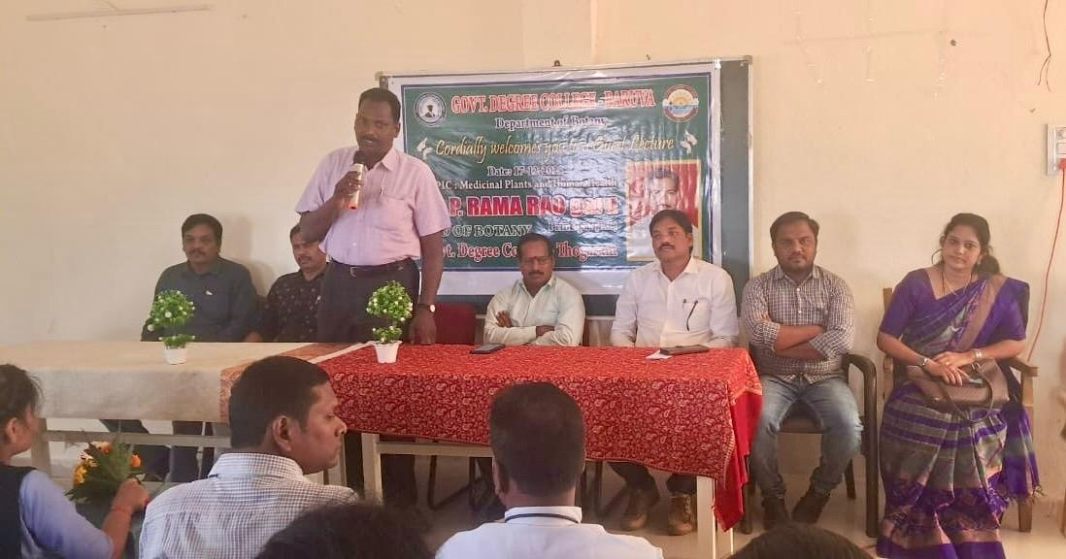

22-12-2025
NATIONAL MATHEMATICS DAY
Smt B.JAGADEESWARI , HOD ,DEPARTMENT OF MATHEMATICS HAVE ORGANISED NATIONAL MATHEMATICS DAY IN THE EVE BIRTH ANNIVERSARY OF SRINIVAS RAMANUJAN,THE GREAT MATHEMATICIAN.

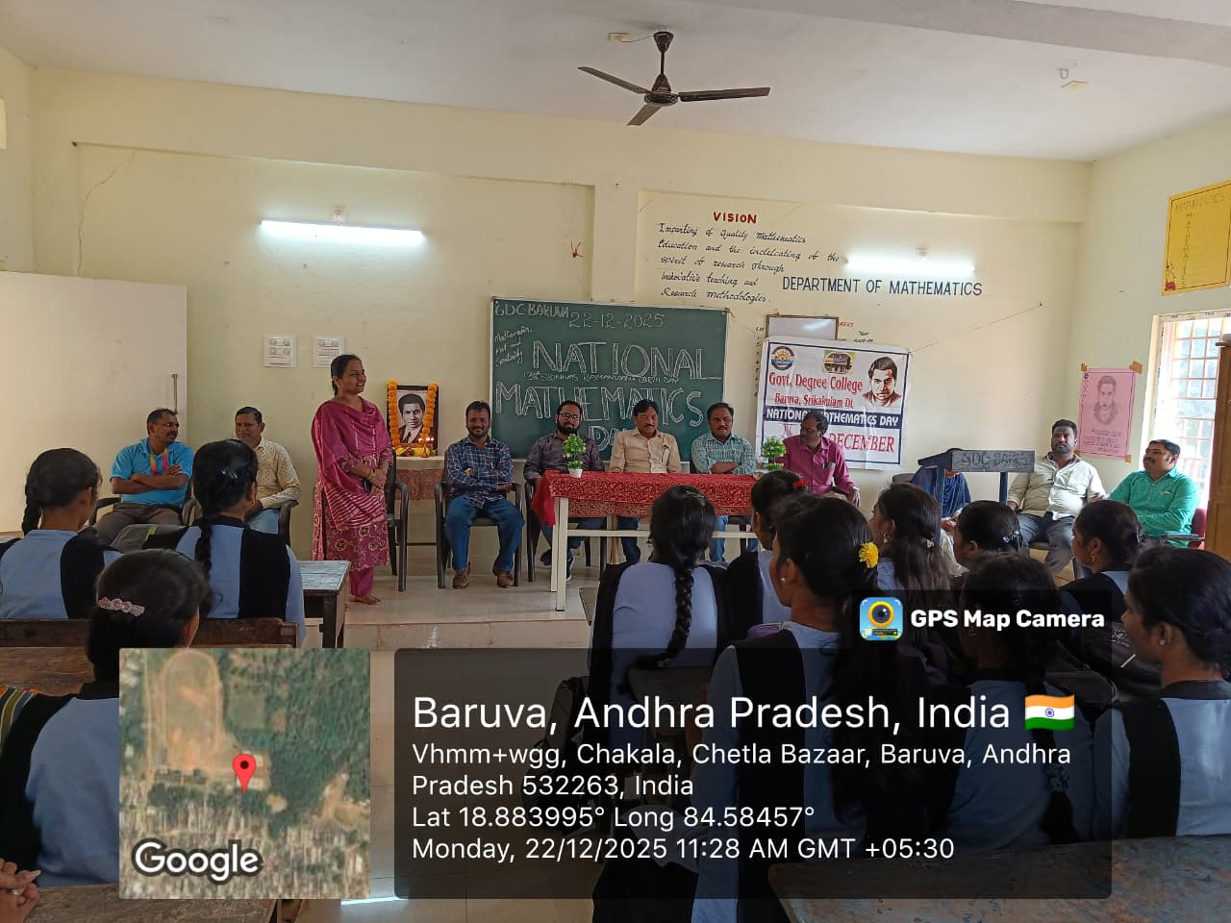
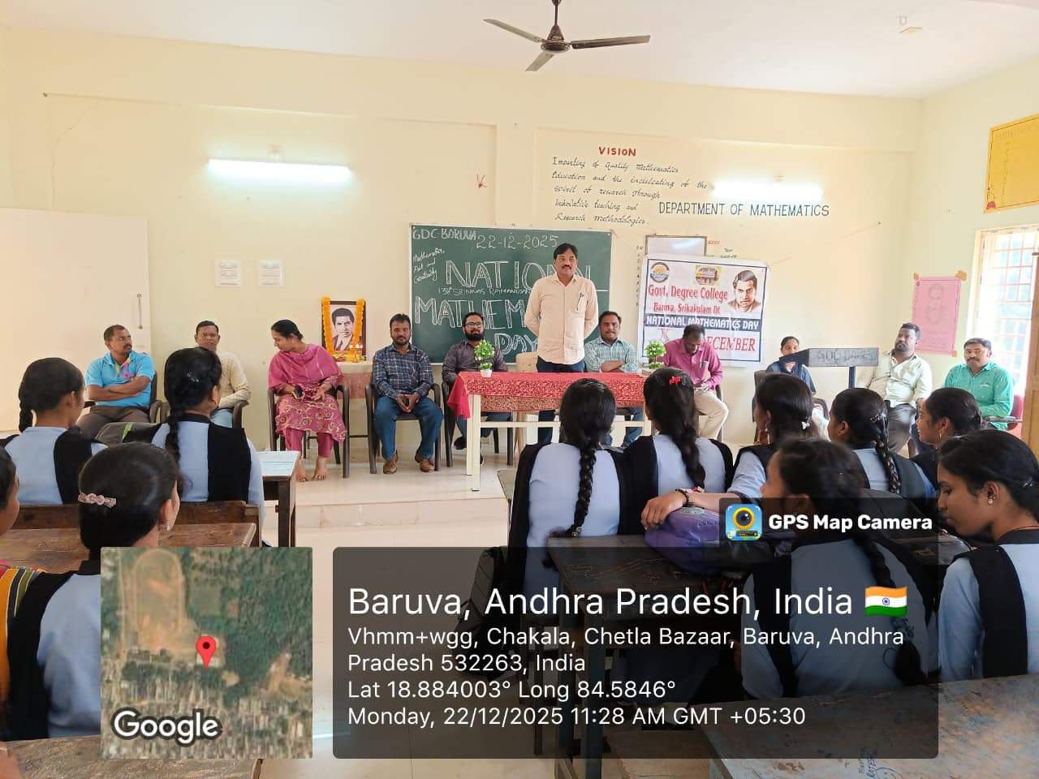
23-12-2025
NATIONAL CONSUMERS DAY
DEPARTMENT OF COMMERCE ORGANISED NATONAL CONSUMERS DAY, COMMERCE LECTURERS EXPLAINED THE CONSUMERS PROTECTION ACT 2019 TO THE STUDENTS.
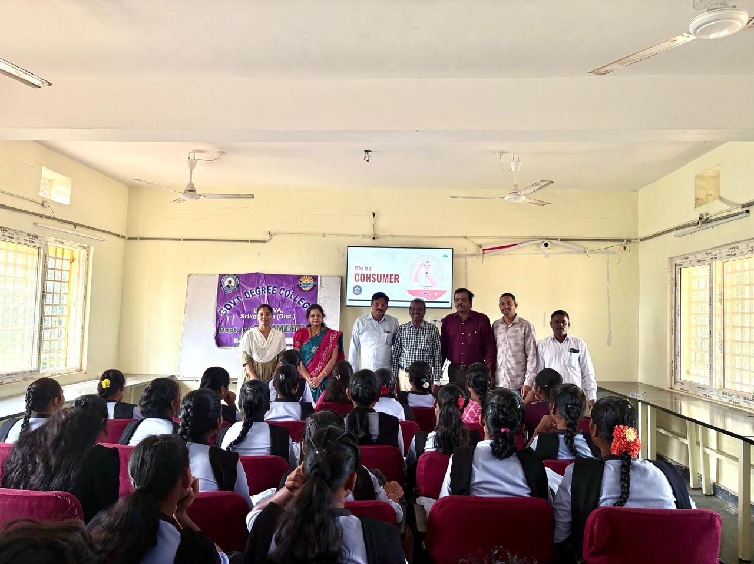 | 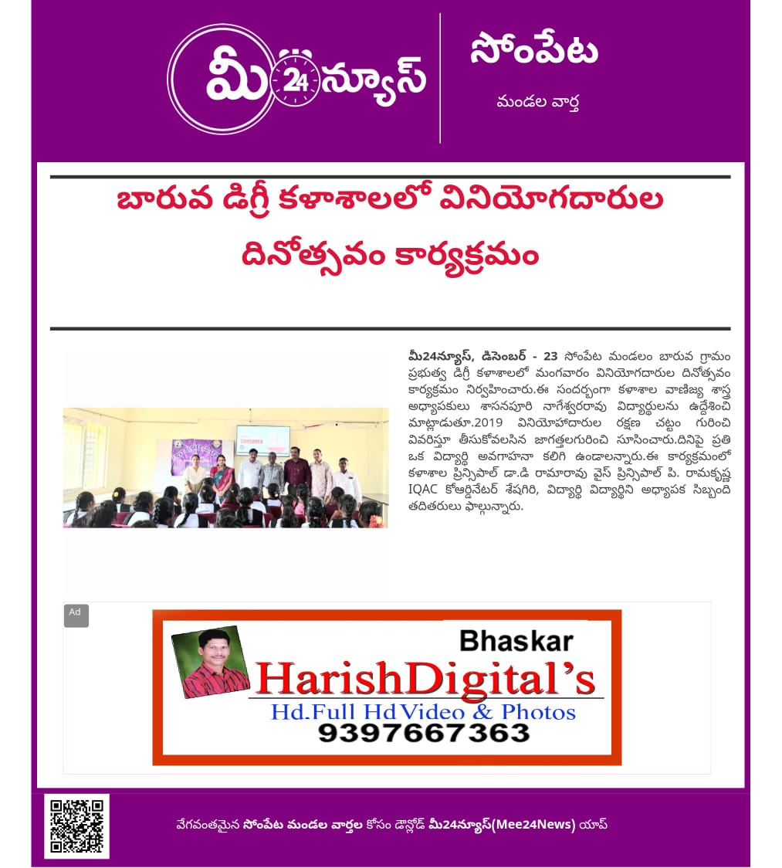

NEWS PAPER CLIPPINGS
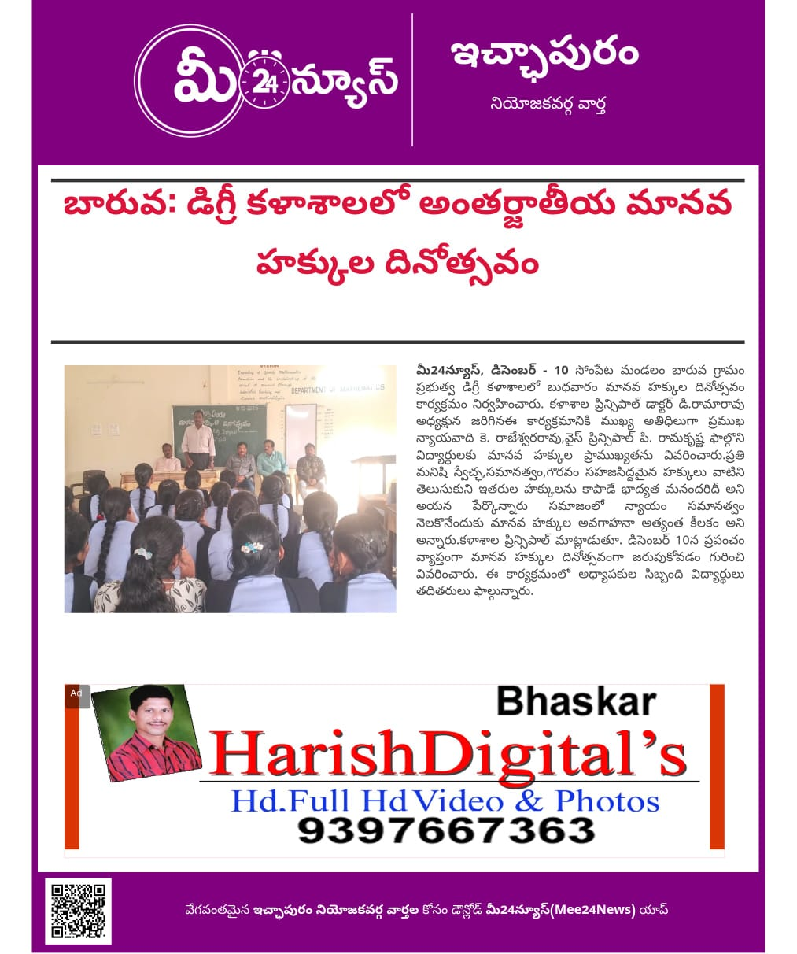

DECEMBER NEWS LETTER- 2025

